TRYHACKME LAB REPORT — WINDOWS BASICS
Internship: DG Interns HUB — Week 2
Platform: TryHackMe
Room: Windows Basics

1. Aim
To understand basic Windows operating system features and learn how to navigate Windows tools relevant to cybersecurity investigations.

2. Objectives
- Understand the Windows desktop and user interface.
- Learn about Task Manager and system processes.
- Understand Windows settings and administrative tools.
- Identify basic system information.
- Become familiar with Windows security and troubleshooting tools.

3. Introduction
Windows is an operating system widely used on personal computers and in organizations. Security analysts examine Windows systems to understand running applications, user activity, system configuration and potential security issues.

4. Important Concepts

Task Manager
Task Manager displays running applications, processes, CPU usage, memory usage and other system activity.

File Explorer
File Explorer is used to browse files, folders, drives and network locations.

Settings and Control Panel
These tools allow users to manage system configuration, installed applications, devices and user-related settings.

Command Prompt and PowerShell
These command-line tools help administrators perform system administration, retrieve information and investigate system behaviour.

System Information
Windows provides details about the operating system version, hardware, memory and other configuration information.

5. Practical Methodology
- Sign in to TryHackMe.
- Open the Windows Basics room.
- Start the required lab environment, if applicable.
- Follow the room instructions in order.
- Explore the Windows features requested by each task.
- Record answers from your actual observations.
- Capture screenshots of completed tasks.

6. Findings
Complete this section after performing the lab.
- Windows version: [Enter observed version]
- System tools explored: [List tools]
- Processes or system information examined: [Record observations]
- Important concept learned: [Describe your learning]
- Task completion status: [Enter actual status]

7. Security Relevance
Windows knowledge helps SOC analysts investigate running processes, suspicious applications, user activity and configuration changes. Understanding normal system behaviour makes it easier to identify activity that needs further investigation.

8. Evidence Checklist
- Screenshot of the room.
- Screenshots of important Windows tools.
- Completed room tasks.
- Actual answers and observations recorded.

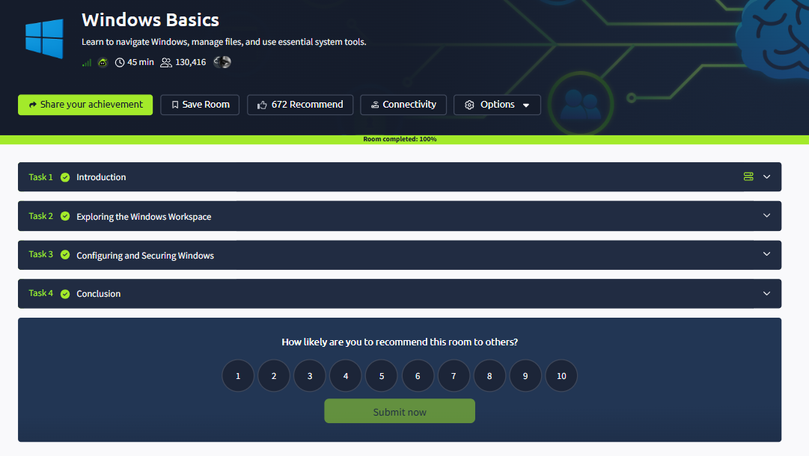

9. Conclusion
This lab develops familiarity with Windows system tools and basic operating system functionality. These skills provide a foundation for Windows event log analysis and endpoint investigations.

